25 September 2024 postcard

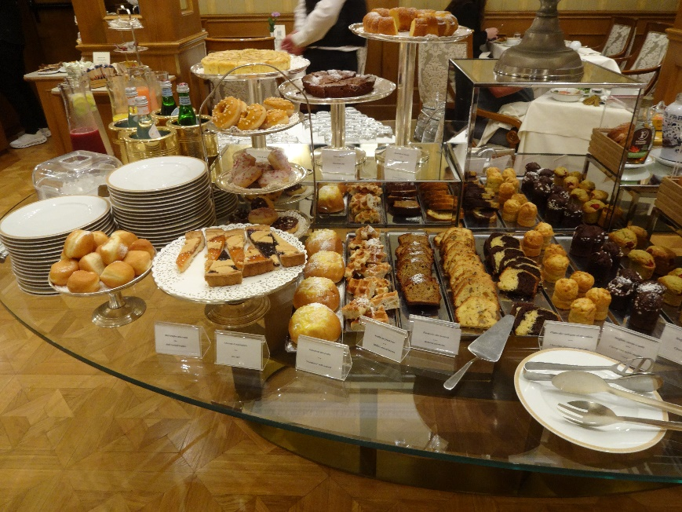The Grand Hotel Majestic in Bologna is clearly under the same ownership and management as the Due Torri Hotel in Verona. In fact the "due torri" are almost certainly the two tradmark towers of Bologna rather than anything to do with the hotel in Verona. So we get all the same toiletries, the same breakfast (well, maybe a little better selection of cakes and pastries), same "juice boxes" of complementary mineral water, even the same half-pound tasseled fobs on our room keys as at the other one.

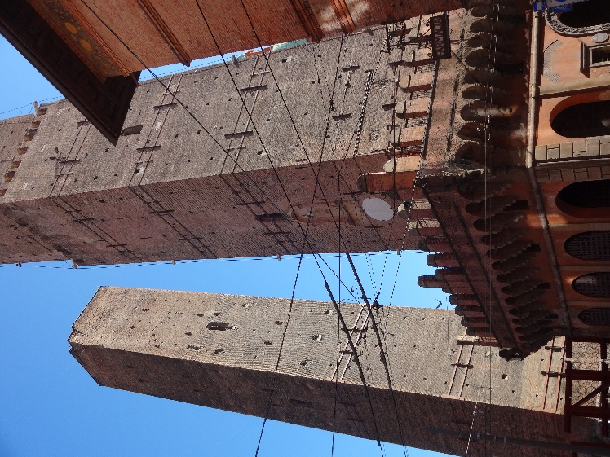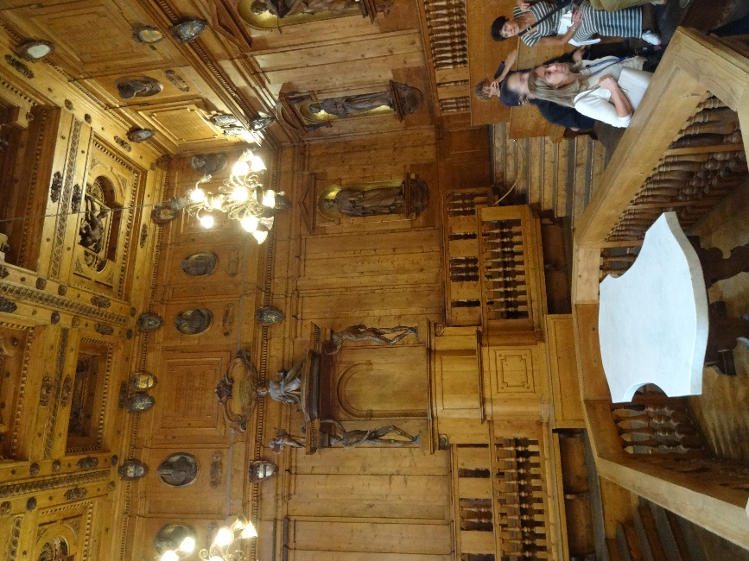We started the day at 9:20 am with an extra-long walking tour of the old city. It took us through Neptune Square, the Great Square, a narrow little food-shopping street, the basilica of St. Petronio (four churches in one, plus a courtyard *and* a cloister), the Church of St. Stephano, the old buildings of Bologna University (including the famous anatomical theater and the hall where law lectures were held), and chances to photograph the famous two towers, now closed to visitors because the shorter one is leaning farther than the tower in Pisa and will shortly fall over (like, within months) unless current stabilization efforts are successful.

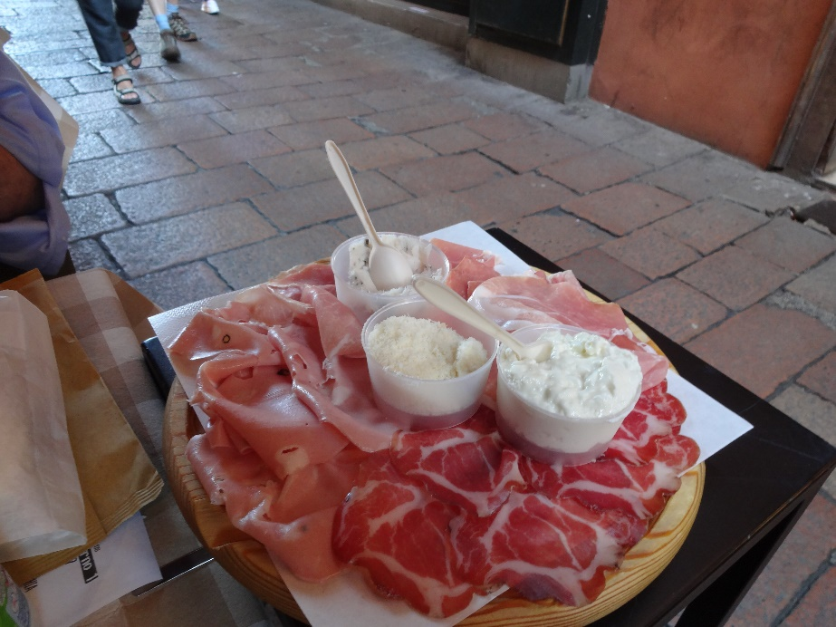After the tour, we went back to the little shopping street and sat at one of their outside tables (there were none inside). David had lasagna, I had tortellini in brodo (in broth), and we split a cold-cut board. For dessert, we had gelato cones from a shop we passed on the way back to the hotel. The cathedral is actually directly across the street from our hotel, so we went in there to look around before going back to our rooms.

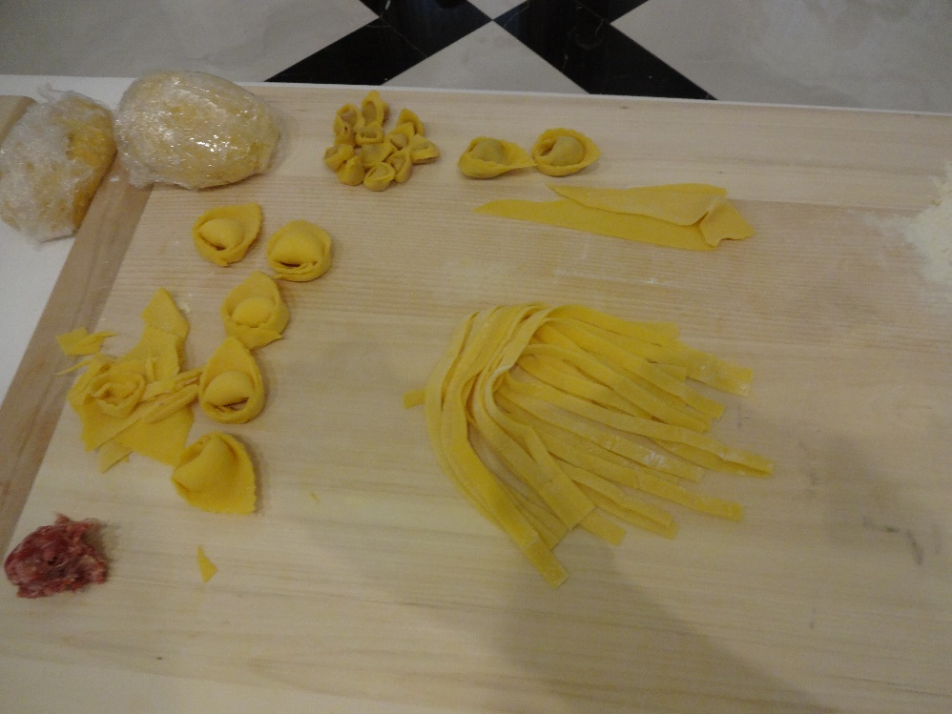At 5:30 pm, we had a pasta-making lesson that Tauck had arranged. Here's my board showing what I made: a dozen meat-filled tortellini (left-over meat filling at the lower left), five cheese tortelloni and two meat-filled ones, and a handfull of fettucini.

Then a cocktail hour arranged for our group, followed by a dinner featuring the pasta shapes (though not the actual pasta) we had made.

A fun day. Tomorrow, off by train to Venice!